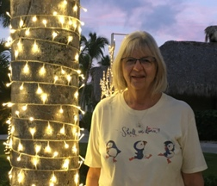November 22, 2024. Temp 32°, cloudy with rain and snow. The leaves continue to swirl around just to annoy me again this year. The wind blew so hard that the leaves covered the front yard two minutes after I had cleared them.

Donna and I will be celebrating our 22st anniversary in a few days. It seems like yesterday that we were getting married. How time flies. She still lights up my life! No electricity needed!

I am a little earlier with the Lanza newsletter this year as we will be in Europe, traveling to France, Switzerland, Germany and Luxembourg, over the Christmas holidays. We plan to visit the Christmas markets in the different cities.

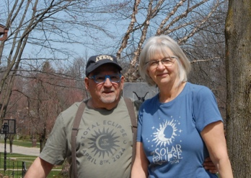

My son Benjamin and grandson Benjamin J. visited us just two weeks ago. They both needed a break from their busy work schedules. It was nice to have them here. Big Ben from Washington State and little Ben from Cincinnati. Robin was unable to come as she had foot surgery and was unable to walk. Olivia is finally in her last quarter at the university, looking forward to when she can get fulltime employment.

 We celebrated last Christmas in Puta Cana with Donna’s daughter Melissa, Ryan and their kids. The resort provided us with plenty of food, swimming, food, walking about, food, stuff for the kids to do and, did I mention food. Everyone had good time.

Abree received special recognition for her art project, a sculpture of a frog. Caleb is on the football junior varsity team, and Bryson has exceeded at a ping-pong class. They grow up so fast.

Donna uses her time volunteering and taking care of her friends/older patients. Once a nurse, always a nurse. We took part in viewing the eclipse and used a special filter on the camera for Pictures.

This year’s projects included us redoing our family room. Donna painted and I did the electrical track lighting. Making it look bigger and brighter with new carpet also. What a difference it all makes.

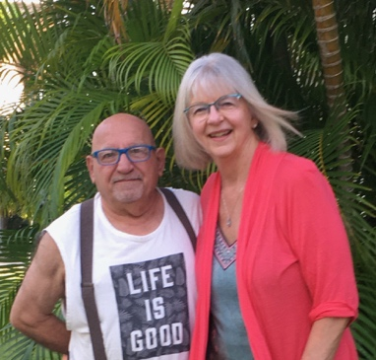

Memories’: in the fifties, we had an eight-foot fence at the back of our yard, behind the fence was a Chestnut tree and an Elderberry bush/tree. We would harvest the chestnut and the Elderberries. You could always tell when we did the Elderberry tree, as we were the color of purple on our faces and hands, but they were so good tasting!

We also had a peach and apple trees in the back yard. Our neighbor (who was also my Mom’s aunt) had one or two fig trees. Needless to say, I for one, sampled all the fruits to their dismay and was punished accordingly. Hey I was just a kid! It was my duty to make sure the fruits were ripe, tasty and ready to eat.

To those of us who have lost relatives and friends, you have our sympathy and our prayers. We will all miss them dearly.

To you, our family, our friends, with love, respect and admiration, we wish you all a wonderful Christmas, and a Happy, Healthy, New Year! So. Until next year, we wish you and yours the best that life can offer.

Ben & Donna

Please send me your email address, as it may be too expensive to mail cards next year. Thanks

blqt@nls.net